7.1 Absolute Value

$$\left|a\right|=\left\{\begin{aligned}a, if a≥0 \\ -a, if a<0\end{aligned}\right\}$$
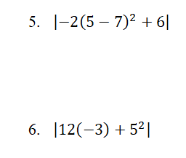
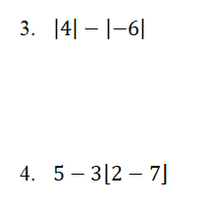
- $\left|3\right|$

- $\left|-7\right|$

A stock on the Toronto Stock Exchange (TSX) opened the month at $13.55 per share, dropped to $12.70, increased to $14.05, and closed the month at 13.85. Determine the total change in the value of this stock for the month. This total shows how active the stock was that month.

7.2 Absolute Value Functions

Graph the Absolute value of $f\left(x\right)=\left|x\right|$

- Graph $g\left(x\right)=\left|2x-3\right|$

- Determine the domain and range of both functions above.

- Express as a piecewise function.

Graph the absolute value function of the form $f\left(x\right)= \left|-x^{2}+2x+8\right|$

- State the domain and range

- Express as a piecewise function

7.3 Absolute Value Equations

- $\left|x-3\right|=7$

- $\left|6-x\right|=2$

- $\left|2x-5\right|=5-3x$

