Chapter 6 – Linear Equations and Inequalities
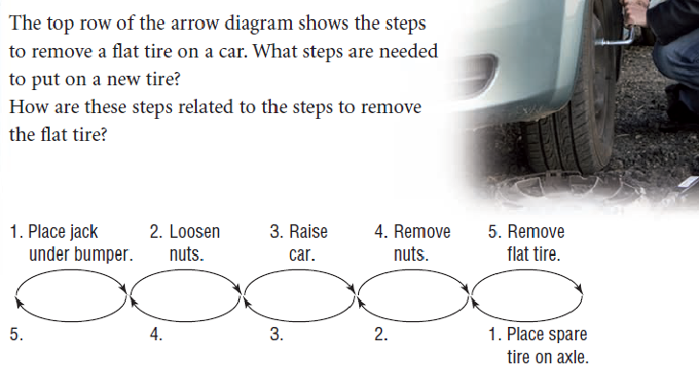
6.1 – Solving Equations by using Inverse Operations

Inverse Operation: – you want to undo what is happening to the variable (do the opposite).
The inverse of:
Adding is _______________________ & Subtracting is ____________________
Multiplying is ____________________ & Dividing is ______________________

Squaring is ______________________ & Square rooting is _________________

Equation – has a variable and an equal sign. When solving, your goal is to get the variable by itself.
However the equation is like a balance beam, you want to keep both sides balanced, or equal. So what you do to one side of the equation you must do to _______________.

Example 1 Writing and Solving a One-Step Equation
For each statement below, write then solve an equation to determine each number. Verify the solution.
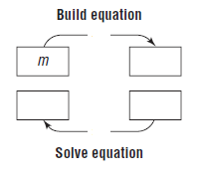
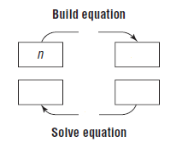
- Three times a number is -3.6 b) A number divided by 4 is 1.5.

Example 2: Solving a one-step equation
Solve to following equations. Verify the solution.
- x + 4 = 6 b) 2.4 + x = 6.3 c) x – 7 = 12 d) 2x = 14 e) $\frac{x}{3}$ = 5
Map:

Algebraically:

Check:

When we simplify an expression like -2(5-1)² + 4, we have learned that the order in which we perform the operations is according to BEDMAS.
When we solve for a variable (isolate the variable or get the variable by itself), we have to do the reverse of the above order which means we will always ______________ or subtract from both sides of an equation first!
Example 3: Solving a Two-Step Equation
Solve, then verify the equation.
- $4.5d-3.2=-18.5$ b) $\frac{r}{4}+3=7.2$

Assignment: Page 271 #2, 4, 5-9
6.1 – Solving Equations by using Inverse Operations- Day 2
Ex: For each statement below, write then solve an equation to determine each number. Verify the solution.
- Five times a number is -20.5. 2. A number divided by 6 is 2.3.

- Write and sole the equation that can be used to determine the width of the rectangle that has a length of 4 cm and a perimeter of 13.2 cm.

- 8 percent of a number is 44.2.

MATH VOCABULARY FOR WORD PROBLEM SOLVING: Fill in each rectangle with other ways to say these words:
Equality =

______________________________________

______________________________________

______________________________________

Addition +  ______________________________________  ______________________________________  ______________________________________ | Subtraction –  ______________________________________  ______________________________________  ______________________________________
Multiplication x  ______________________________________  ______________________________________  ______________________________________ | Division ÷  ______________________________________  ______________________________________  ______________________________________
Assignment: Page 273 #10, 11, 13-20, choose either 21 or 22 and answer it!
DECODING WORD PHRASES

Underline the key vocabulary words in the verbal phrases below, writing the math language below the phrase. Then, match your phrase with the mathematic expressions on the right to verify your answer. The first problem is completed for you.
Math Equation or Verbal Sentence | Match | Equality
1. The sum of a number and 8 is 20.  n + 8 = 20 | d | a. 7 + n = 2n
2. Six times a number less five equals 55. |  | b. 2n – 8 = 12
3. Seven plus a number is equal to twice that number. |  | c. n ÷ 8 = 96
4. The product of 4 and a number is 85. |  | d. n + 8 = 20
5. The quotient of a number and 8 is 96. |  | e. 4n = 85
6. 4 increased by 10 times a number is 100. |  | f.
7. The difference between 2 times a number and 8 is 12. |  | g. 6n – 5 = 55
8. The quotient of 2 times a number and 8 is 3. |  | h.
9. The difference between ¾ of a number and 5 is 82. |  | i. 4 + 10n = 10
10. Create your own verbal sentence. |  | j.

Verbal Phrase | Match | Math Expression
1. Fifteen less seven  15 – 7 | e | a. n + 4
2. The product of three and eight |  | b. 20 – 15
3. Fifteen less than twenty |  | c. 6 – n
4. Four more than a number |  | d. 3 · 8
5. The difference of six and a number |  | e. 15 – 7
6. The quotient of 10 and a number |  | f. (n + 6) – 15
7. 15 less than the sum of a number and 6 |  | g. 10 ÷ n
8. Three more than eight times a number |  | h.
9. The difference between 3 times a number and 6 |  | i. 8n + 3
10. A number divided by the sum of 10 and 2 |  | j. 3n – 6

6.2 – Solving Equations by Using Balance Strategies
To solve an equation, we need to _______________ the variable on one side of the equation. This means that we need to get the variable _____________ on one side of the equation. When the variable is isolated, its coefficient is _______.
In an equation, the value of the left side of the equal sign is equal to the value of the right side of the equal sign. So, when we solve an equation and in doing so try to get the variable alone, we must make sure that we keep the equation ___________________. To do this, we say “what you do to one side, you must do to the other!”
Does it matter which side of the equation we isolate the variable on?
$2x+5=4x-5$
Solve by bringing the x’s to the left Solve by bringing the x’s to the right

Examples:
- Solve the following equations & verify your solution.
a. 6x + 2 = 10 + 4x b. -3c + 7 = 2c – 8 c. $2n+3=2+n$

Assignment: Page 280 #2, 4, 6 (use balance strategy), 10, 11, 17
6.2 – Solving Equations by Using Balance Strategies Day 2
Solving Equations with Rational Coefficients
Example 1: Solve each equation, then verify the solution.
- $\frac{122}{r}=3 , r≠0$ b) $\frac{2a}{3} = \frac{4a}{5} + 7$

Example 2: A cell phone company offers two plans:
Plan A: 120 free minutes, $0.75 per additional minute
Plan B: 30 free minutes, $0.25 per additional minute
Which time for calls will result in the same cost for both plans?
- Model the problem with an equation
- Solve the problem
- Verify the solution

Therefore, the cost is the same for both plans when the time used for calls is ________minutes.

Assignment: page 281 # 8, 9, 12 – 14, 16a, 18, 19, 21
6.3 – Introduction to Linear Inequalities
- Equations can be used to find an unknown value, x. For our purposes in grade 9, there will only be one value for x that works in the equation and makes the left side equal the right side.
Ex: 4 + x = 6 , therefore x =

- Inequalities can also be used to find an unknown value(s) for x. However, instead of their only being one value that works, there will be a range of values that will satisfy the inequality.
Ex: x > 5 means that x can be
The Solution of the Inequality - Each number that makes the inequality ________
The different types of Inequalities:
> - ____________________________ ≥ - __________________________________
< - _____________________________ ≤ - __________________________________
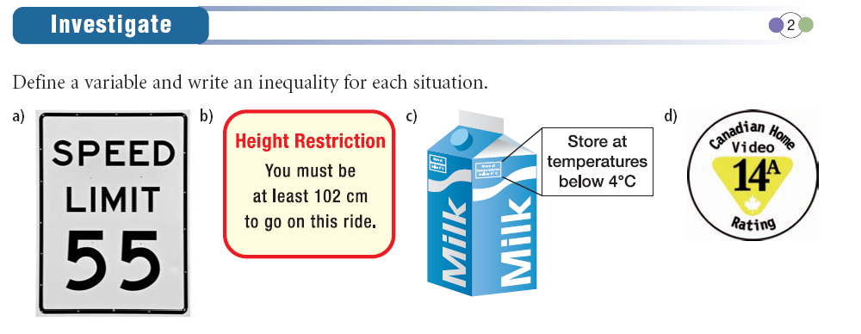
Examples:
- Define a variable and write an inequality to describe each situation:
  - Contest entrants must be at least 18 years old.

  - The temperature has been below -5˚C for the last week.

  - You must have 7 items or less to use the express checkout line at a grocery store.

  - Scientists have identified over 400 species of dinosaurs.

- Is each number a solution of the inequality b ≥ -4? Justify the answers.
  - -8
  - -3.5
  - -4
  - -4.5
  - 0
Graphing - ____and ____does not include the number, this means you have an open circle on your
number in your graph
____ and ____ does include the number, this means you have a closed circle on your
number in your graph.

- Graph each inequality on a number line:
  - t > -5

  - -2 ≥ x

  - -0.5 ≤ a

  - p < -25/3

Assignment: Page 292 #3, 6-10, 12, 13, 15

6.4 – Solving Linear Inequalities by Using Addition and Subtraction
To solve a linear inequality you use the same steps you would with an equal sign.
Does the direction of the inequality stay the same when you do each of the following?
- Add the same positive or negative number to both sides? Y N
- Subtract the same positive or negative number from both sides? Y N

Examples:
- Solve the inequality, verify the solution and graph the solution:
  - 6.2 ≤ x – 4.5

- Solve each inequality. Graph the solution. Verify the solution.
- x + 5 > 2 b) 4t - 19 < 24 + 3t

- Jake plans to board his dog while he is away on vacation.
  - Boarding house A charges $90 plus $5 per day.
  - Boarding house B charges $100 plus $4 per day.
For how many days must Jake board his dog for boarding house A to be less expensive than boarding house B?

Assignment: Page 298 #7-9, 11ab, 12, 13
6.5 – Solving Linear Inequalities by Using Multiplication and Division
Inequality Operation on Both Sides New Inequality
12 > 6 Multiply by 3

12 > 6 Divide by 3

12 > 6 Multiply by (-3)

12 > 6 Divide by (-3)

12 > 6 Multiply by 2

12 > 6 Divide by 2

12 > 6 Multiply by (-2)

12 > 6 Divide by (-2)

What happens to the direction of the inequality when you do each of the following?
- Multiply both sides by the same positive number? stay the same reverse
- Divide both sides by the same positive number? stay the same reverse
- Multiply both sides by the same negative number? stay the same reverse
- Divide both sides by the same negative number? stay the same reverse
When each side of an inequality is ________________ or ________________ by the same negative number, the inequality sign must be ________________ for the inequality to remain true.
Examples:
One Step Inequality:
- Solve each inequality and graph the solution:
  - -5s ≤ 25 b. 7a < -28

c. $\frac{y}{-3}$ > -2 d. $\frac{k}{3}$ ≥ -3

Multi- Step Inequality:
To solve an inequality with multiple steps we use BEDMAS backwards. Thus we use ______________ and _________________ to get all the variables on one side (preferably the left side) and the constants on the other. “What you do to one side of an inequality, you must do to the other”.
REMEMBER!!! If you at any point need to multiply or divide by a negative number, you must reverse the inequality sign!
- Solve the inequality and verify the solution. (Note: Verify with three values in the solution region)
-2.6a + 14.6 > -5.2 + 1.8a Verify:

- Solve the inequality and list three possible solutions.
3 + 4x ≤ 7x + 9

Assignment: Page 305 #3, 4, 7 - 9

  - Day 2– Using to Model & Solve a Problem
- A super-slide charges $1.25 to rent a mat and $0.75 per ride. Haru has $10.25. how many rides can Haru go on?
    - Choose a variable, then write an inequality to solve this problem.
    - Solve the problem
    - Graph the solution

- Solve each inequality. Graph the solution.
a) $1 + \frac{ 3}{4}x > 17$ b) $4 - \frac{2}{3} d ≥ \frac{5}{6}d - 5$

c) 2 (3 + 4y) < -3 (3 - y)

Assignment: page 305 # 10, 11(b,d) , 12(Solve only, no verify necessary), 13, 16, 17(a)
Chapter 6 Review Assignment: Page 308 #1-16

